NAME:DIPIKA.K

REG NO:24BHI10064

TITLE

SMART HOSTEL MANAGEMENT SYSTEM

Smart Hostel Management System

Project Overview
The Smart Hostel Management System is a modern backend application developed to simplify and automate hostel administration in educational institutions. Built using Java 21, Spring Boot 3.3.4, and MongoDB, the system provides a secure, scalable, and efficient platform for managing hostel operations digitally.
The application consists of several interconnected modules that work together to streamline daily activities. A secure Authentication and Authorization module uses Spring Security and JWT (JSON Web Tokens) to ensure that only authorized users can access system resources. Role-Based Access Control (RBAC) is implemented with three user roles—Admin, Staff, and Student—allowing each user to access only the features relevant to their responsibilities. User passwords are securely stored using BCrypt encryption.
The system also includes Infrastructure and Room Management features that enable administrators to create departments, manage hostel rooms, monitor occupancy levels, and track room availability in real time. Through the Student and Staff Management module, user profiles can be maintained efficiently while the Hostel Allocation module automatically assigns students to available rooms, preventing room overbooking and improving resource utilization.
To demonstrate extensibility, the project includes a Library Management component where students can borrow and return books. In addition, an Analytics Dashboard provides administrators with key statistics and insights, helping them make informed decisions regarding hostel operations.
For improved developer experience and easier testing, all REST APIs are documented using Swagger UI through Springdoc OpenAPI. This allows developers and administrators to explore and test endpoints directly from a web browser using JWT Bearer authentication.

Conclusion
The Smart Hostel Management System successfully transforms traditional hostel administration into a centralized digital solution. By leveraging the capabilities of Spring Boot and MongoDB, the project delivers a flexible, maintainable, and scalable backend architecture capable of supporting future growth and enhancements.
A major focus of the project was security. JWT-based authentication, role-based authorization, and BCrypt password encryption ensure that sensitive student information and administrative functions remain protected from unauthorized access. During development, several security concerns and API vulnerabilities were identified and resolved, resulting in a more secure and reliable application.
Overall, the project serves as a strong foundation for a complete hostel management ecosystem. It can be seamlessly integrated with modern frontend technologies such as React, Angular, Flutter, or mobile applications to provide a fully functional end-to-end solution. By reducing manual effort, improving data accuracy, and enhancing operational efficiency, the Smart Hostel Management System offers significant value to educational institutions seeking a smarter approach to hostel administration.

Core Technologies Used

Java Development Kit (JDK) 21
Java 21 serves as the primary programming language for the Smart Hostel Management System. It provides modern language features, improved performance, and long-term support, making it suitable for building secure and scalable enterprise applications.

Spring Boot 3.3.4
Spring Boot is the core backend framework used to develop the RESTful APIs. It simplifies application development through features such as dependency injection, auto-configuration, embedded servers, and seamless integration with other Spring modules.

Maven
Maven is used as the project's build automation and dependency management tool. It manages external libraries, handles project builds, and ensures consistent application deployment. The project utilizes the Maven Wrapper (mvnw), allowing developers to build and run the application without installing Maven separately.

Database Technologies

MongoDB
MongoDB is the primary NoSQL database used for storing application data. Its document-oriented structure provides flexibility in handling different types of hostel-related information, including students, staff, rooms, departments, and book records.

Spring Data MongoDB
Spring Data MongoDB acts as the bridge between the application and the MongoDB database. It simplifies database operations by automatically mapping Java objects to MongoDB documents and providing repository-based CRUD functionality.

Security and Authentication

Spring Security
Spring Security is responsible for securing the application and implementing Role-Based Access Control (RBAC). It ensures that only authorized users can access specific resources based on their assigned roles such as Admin, Staff, or Student.

JSON Web Token (JWT)
JWT authentication is implemented using the JJWT library (Version 0.12.5). After successful login, a secure token is generated and provided to the user. This token is used to authenticate subsequent requests, enabling a stateless and secure authentication mechanism.

BCrypt Password Encryption
User passwords are encrypted using the BCrypt hashing algorithm before being stored in the database. This ensures that sensitive user credentials remain protected even if database access is compromised.

API Documentation and Testing

Springdoc OpenAPI (Swagger UI) 2.5.0
Swagger UI automatically generates interactive API documentation for all available endpoints. Developers and testers can view endpoint details, submit requests, and verify responses directly through a browser interface.

Postman
Postman is used for manual API testing and validation. It allows developers to test authentication workflows, CRUD operations, request parameters, and response handling throughout the development lifecycle.

Development Environment

Visual Studio Code (VS Code)
Visual Studio Code serves as the primary development environment for writing, debugging, and managing the project source code. Its extensive extension support improves productivity during development.

Windows Terminal / PowerShell
Windows Terminal and PowerShell are used to execute Maven commands, run the Spring Boot application, manage project builds, and perform various development and deployment tasks.

MONGO DB CONNECTED PORT
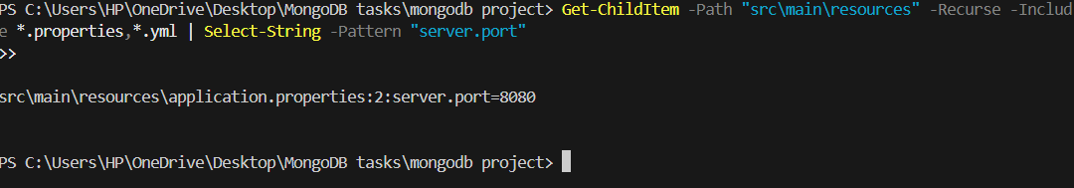

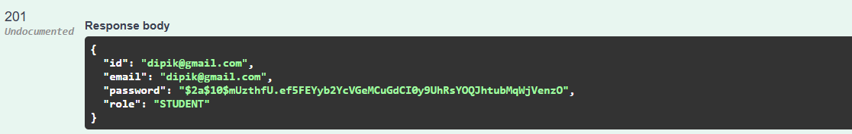
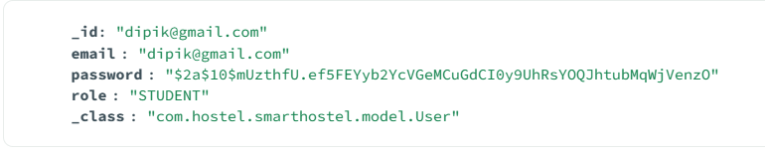
IN MONGODB COMPASS,DATABASESsmart_hostel_dbusers collection, shows the inserted user
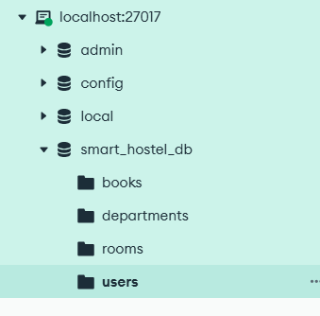
HERE THE PASSWORDS ARE IN THE HAShED FORM AS WE USE bcryptjs IT IMPROVES SECURITY AND SHOWS AUTHENTICATION MODULE IMPLEMENTATION
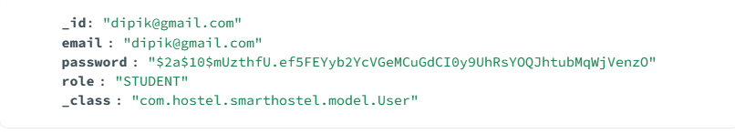
THE USER LOGIN WAS PROCESSED SUCCESSFULLY UPN SUCCESSFUL PASSWORD VERIFICATION THE SYSTEM GENERATED A JWT TOKEN USING THIS TOKEN THE USER CAN ACCESS THE PROTECTED APIS
THEN COPY THE JWT TOKEN AND PASTE IN AUTHORIZE TO GET AUTHORIZED
NOW CHECKING FOR ROOM
